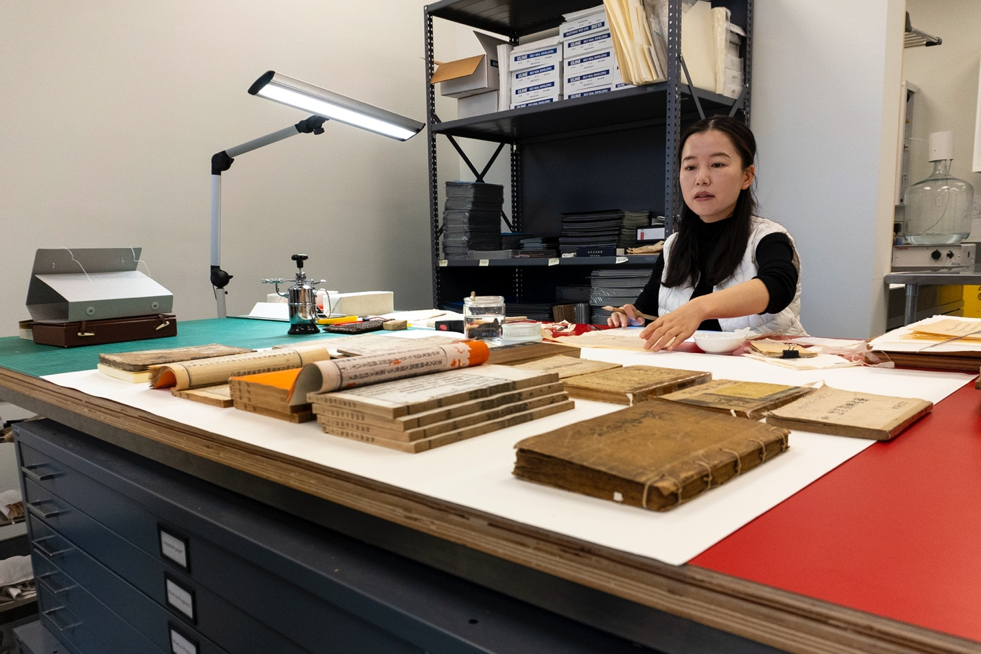

UBC Library

2023/24

Senate Report

Table of Contents

**Message from the University Librarian – Pages 3-4**

* UBC Library and the Indigenous Strategic Plan – Page 4
* UBC Library and the Inclusion Action Plan – Page 4

**Section 1**

* Advance Research, Learning and Scholarship – Pages 5-7
* Fundraising for the future – Page 7

**Section 2**

* Engage with Communities – Pages 8-10

**Section 3**

* Create and Deliver Responsive Collections – Pages 11-13
* UBC Library at a glance – Page 14
* Statement of revenue & expenditures – Page 15

**Section 4**

* Inspire with Innovative Spaces and Services – Pages 16-18

**Section 5**

* Steward the Organization – Pages 19-20
* UBC Okanagan Library Highlights – Page 21
* Acknowledgements – Page 22

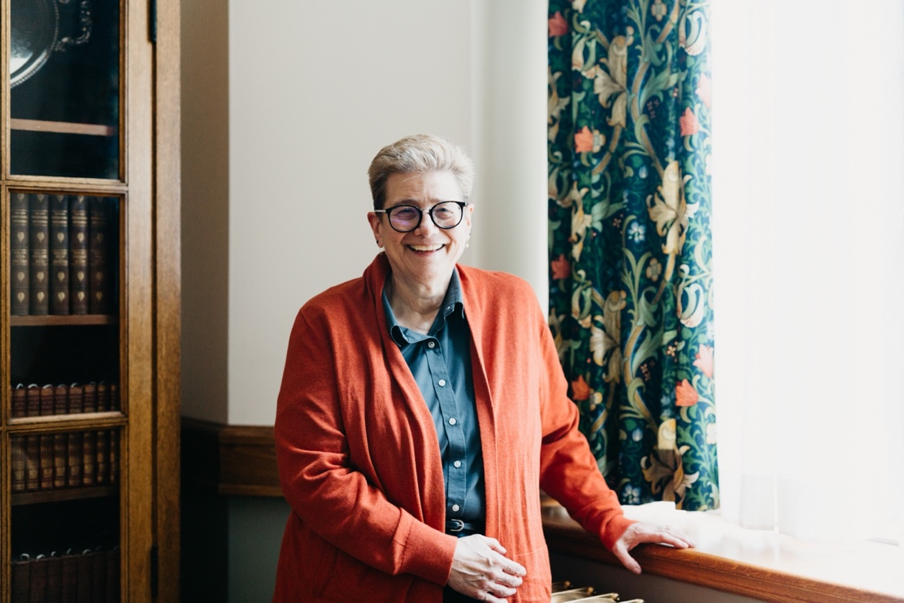

# Message from the University Librarian

2023/2024 has been a year of milestone moments for the library. Our Conservation Space welcomed the inaugural conservator from Fudan University for a 100-day visit, as part of a cultural and knowledge exchange. We celebrated 30 years at X̱wi7x̱wa Library with the First Nations Longhouse. Construction on the Chung | Lind Gallery continued throughout the year in anticipation of its official opening in April 2024.

However, these celebrations may feel cut short as the 2024/2025 fiscal year has begun, and the library is left without the same level of financial support we rely on from the university. UBC Library did not receive all of the supplemental funding that has typically been distributed to us by the university each year, and which historically have covered PTR merit, 2% of the collection cost towards inflation, and the dollars needed to cover the exchange rate.

The impacts to the library that this will have on the 2024/2025 fiscal year are not yet fully known, but we already making budget decisions to mitigate this loss of funds and focus on the basic maintenance of library services and facilities. Under these new financial pressures, this report is likely look very different next year.

– Dr. Susan E. Parker

## UBC Library and the Indigenous Strategic Plan

The library finalizes a three-year Library Equity and Inclusion Action Plan, based on the principles of the UBC Inclusion Action Plan (IAP). The plan prioritizes 14 different project areas, including updates to hiring, training and professional development, internal operations processes, improving space and accessibility within library facilities, and more. The work identified in this plan can make a tangible, lasting impact on equity-deserving groups who work at or use the library.

UBC Library’s Equity, Diversity and Inclusion (EDI) Scholars-in-Residence program enters its second year, welcoming three new Scholars to the Irving K. Barber Learning Centre for the 2023/2024 academic year.

## UBC Library and the Inclusion Action Plan

The library develops a basic Indigenous reference training workshop to address the growing demand and expand capacity for Indigenous reference help across the UBC Library system. In August 2023, three live training sessions are offered, attended by nearly 50 UBC Library employees, for whom this work directly intersected with their job duties. A second roll-out is offered in March 2024 specifically for student librarians and UBC iSchool students.

In March 2024, the Library Leadership Team participates in the first of three meetings devoted to working through the Indigenous Strategic Plan (ISP) Intent to Action Tool. Through this work, the library can meaningfully engage with the ISP by identifying goals, actions, and activities that fall within our sphere of influence.

# **Section 1**

Advance Research, Learning and Scholarship

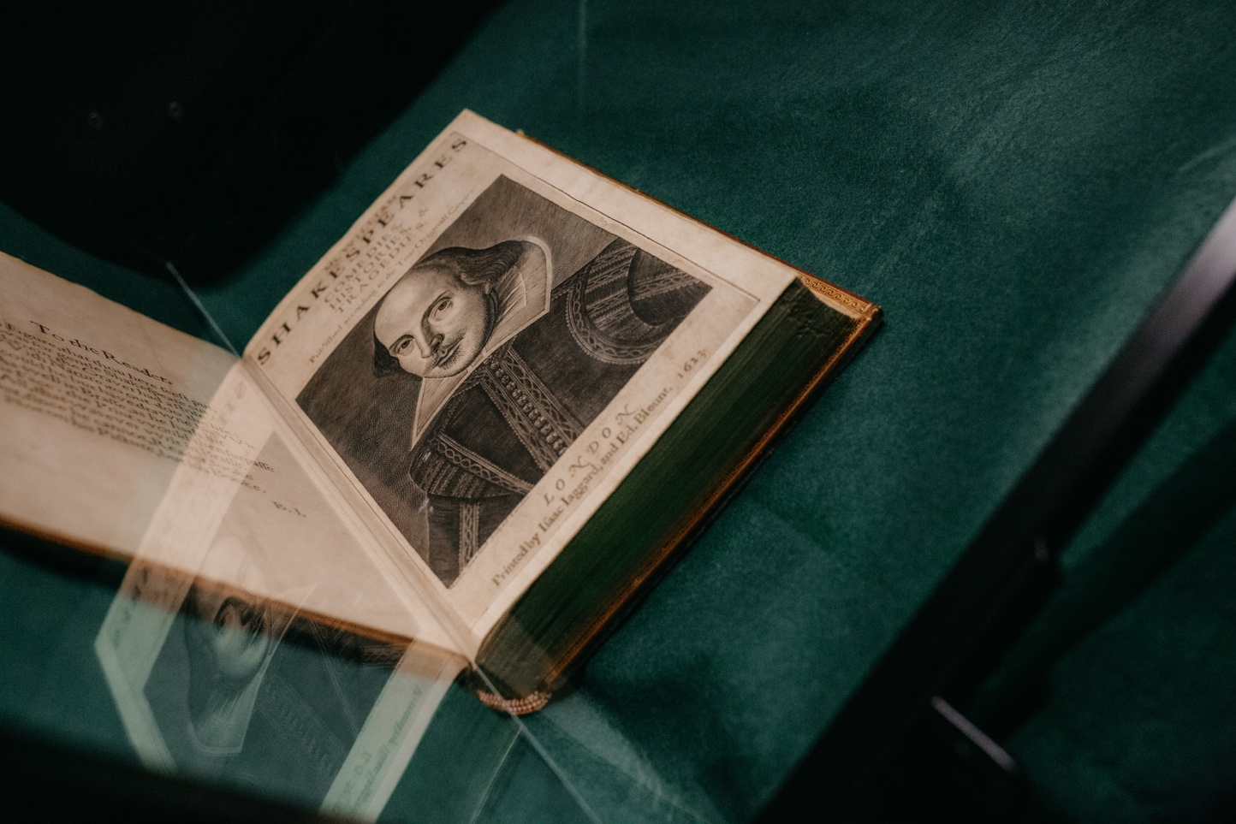

Articles: Advance Research, Learning and Scholarship

* UBC Open Educational Resource Project Virtual Showcase
* Education Library supports community field experience
* First Folios Compared
* Shakespeare xR
* Photographs Conservation workshop
* Canadian Certificate in Digital Humanities
* Fundraising for the Future

# UBC Open Educational Resource Project Virtual Showcase

UBC Library, UBC Okanagan Library and the UBC Centre for Teaching, Learning and Technology host a virtual showcase event for open educational resource creators, introducing a new way for faculty, staff, and students to learn about these innovative projects.

# Education Library supports community field experience

As a community field experience partner, the Education Library offers teacher candidates the opportunity to explore a non-traditional educational space. Teacher candidates work directly with UBC librarians to develop projects that align with ongoing initiatives at the branch that can tie into their future work as teachers.

# First Folios Compared

UBC Library supports landmark Open Access project First Folios Compared by contributing the digitized version of UBC’s first edition of *William Shakespeare’s Comedies, Histories, & Tragedies* to a collection of 47 unique digital folios, sourced from 23 locations. As a participating institution, UBC Library joins a distinguished, global list of contributors.

# Shakespeare xR

UBC Library supports Shakespeare xR, an innovative project spearheaded by UBC’s Emerging Media Lab and the UBC Department of Theatre and Film. Using the library’s digitized version of UBC’s First Folio, Shakespeare xR reimagines classic Shakespearean characters across different technological media such as web-based augmented reality, artificial intelligence and an interactive touch table.

# Photographs Conservation workshop

UBC Library’s Conservation Space hosts conservator Chloé Lucas for a two-day workshop on archival photograph identification, conservation and preservation. Following a lecture on photographic processes, conservation treatments and condition reporting, participants spend time in the Conversation Space, getting hands-on practice.

# 

Canadian Certificate in Digital Humanities

UBC Library announces a new partnership with the Canadian Certificate in Digital Humanities/Certificat canadien en Humanités Numériques (cc:DH/HN), which offers a certificate for those participating in non-curricular digital humanities workshops. Eligible workshops offered by the UBC Library Research Commons can now count towards completion of this new certificate.

# 

# Fundraising for the Future

Donor support enables the library to enhance student learning, helps researchers find answers and advances knowledge to its fullest potential. Donations can help build spaces, connect ideas, and allow the library to provide a margin of excellence beyond what public dollars provide.

Inbound channels

**24%** – Web

**23%** – Mail

**17%** – Personal solicitations

**12%** – Phone

Total funds raised

**$1.1** Million

Number of gifts

**422**

Funds raised

**$518K** – Pledges

**$393K** – Gifts-in-kind

**$232K** – Outright donations

# 

# **Section 2**

Engage with Communities

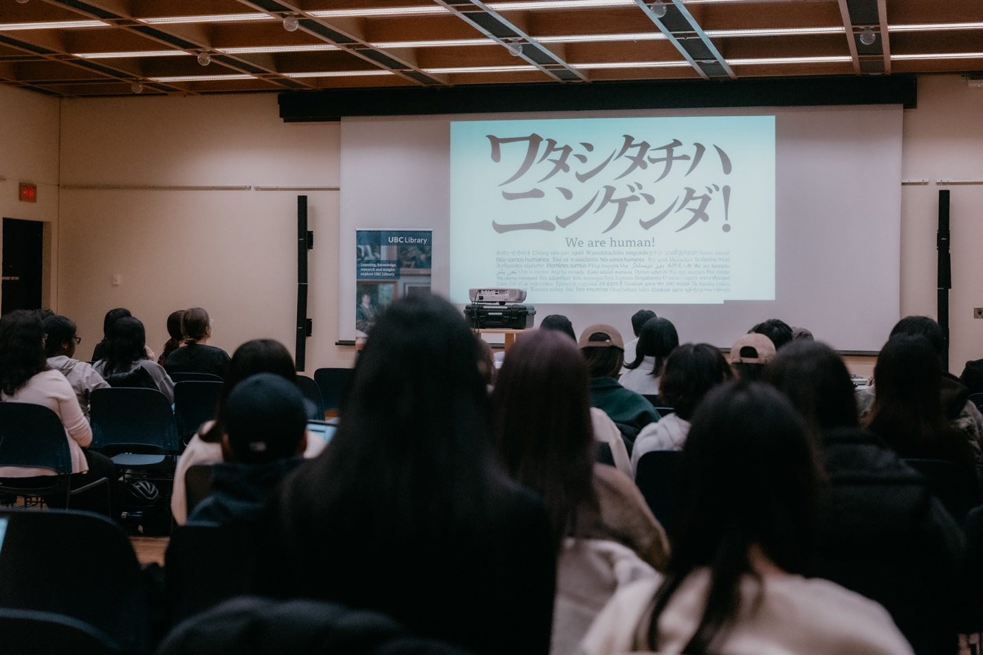

Articles: Engage with Communities

* Air Travel Decision Tree
* Carbon emissions workshop
* NOIIE Partnership
* X̱wi7x̱wa Library 30th Anniversary
* WE ARE HUMAN!: Documentary Film Screening and Panel Discussion
* Supporting Vancouver Black Library’s outreach and expansion
* Coast Salish Two-Spirit Pride Mosaic installed
* Word Vancouver Reading & Writing Festival 2023
* Collaboration on Foundations of Decolonization series

# Air Travel Decision Tree

With greenhouse gas emissions still on the rise globally, faculty and staff at UBC are weighing the ethical impacts of work-related air travel. UBC Library builds a two-page framework document that guides individuals through the decision-making process for work-related air travel. The Air Travel Decision Trees gains momentum through other faculty-led sustainability groups across the university.

# Carbon emissions workshop

UBC’s Climate Action Plan (CAP 2030) include goals toward significantly reducing greenhouse gas emissions on both campuses by 2030. With funding provided by a UBC Library Innovation Grant, the library holds a workshop on finding ways to lower carbon emissions. Workshop participants discover where emissions exist in libraries and what changes we can make to have the most impact.

# NOIIE Partnership

UBC Library’s Irving K. Barber Learning Centre reflects on 10 years as a funding partner for the Networks of Inquiry and Indigenous Education (NOIIE) and the critical role this organization fulfills at participating schools and school districts across British Columbia.

# X̱wi7x̱wa Library 30th Anniversary

In honour of the First Nations Longhouse and X̱wi7x̱wa Library’s 30th anniversary, as well as National Indigenous Peoples Day, the First Nations House of Learning and the library jointly hold an open house. The UBC community is invited to participate in self-guided tours and informative talks with faculty and staff.

# WE ARE HUMAN!: Documentary Film Screening and Panel Discussion

# 

UBC Asian Library and the Department of Asian Studies host a film screening and panel discussion of *Watashitachi wa Ningen da! (We are Human!)*. This award-winning film interrogates Japan’s immigration policies and casts reflections on British Columbia’s relationship with its migrant foreign workers.

# Supporting Vancouver Black Library’s outreach and expansion

UBC Library and the Vancouver Black Library (VBL) gain grant funding through UBC Community Engagement’s Partnership Recognition and Exploration (PRE) Fund, which will support programming and outreach events at the VBL in addition to the expansion of the collection’s bookshelves.

# Coast Salish Two-Spirit Pride Mosaic installed

A new installation is revealed at an event hosted by the First Nations House of Learning. The Coast Salish Two-Spirit Pride Mosaic is a visual representation of Coast Salish Two-Spirit unity, dignity and respect designed by xʷməθkʷəy̓əm (Musqueam) artist kʷəlasəltən (Mack Paul). This installation is a collaboration between the Equity & Inclusion Office, Campus + Community Planning with support from First Nations House of Learning and X̱wi7x̱wa Library.

# Word Vancouver Reading & Writing Festival 2023

UBC Library and Word Vancouver are awarded a grant of $5,000 from UBC Connects at Robson Square. Funded by the grant, the Word Vancouver Literary Festival 2023 is part of the university’s efforts to host free, accessible programming and help transition UBC Robson Square into a centre of public engagement.

# Collaboration on Foundations of Decolonization series

Foundations of Decolonization, a monthly speaker series produced by the University of Victoria, expands their audience to include library faculty and staff from UBC and SFU. The first conversation features Kayla Lar-Son, Acting Head of X̱wi7x̱wa Library, who explores the concepts and complexities of Indigenous Data, Knowledge, and Cultural Sovereignty and how it relates to libraries.

# **Section 3**

Create and Deliver Responsive Collections

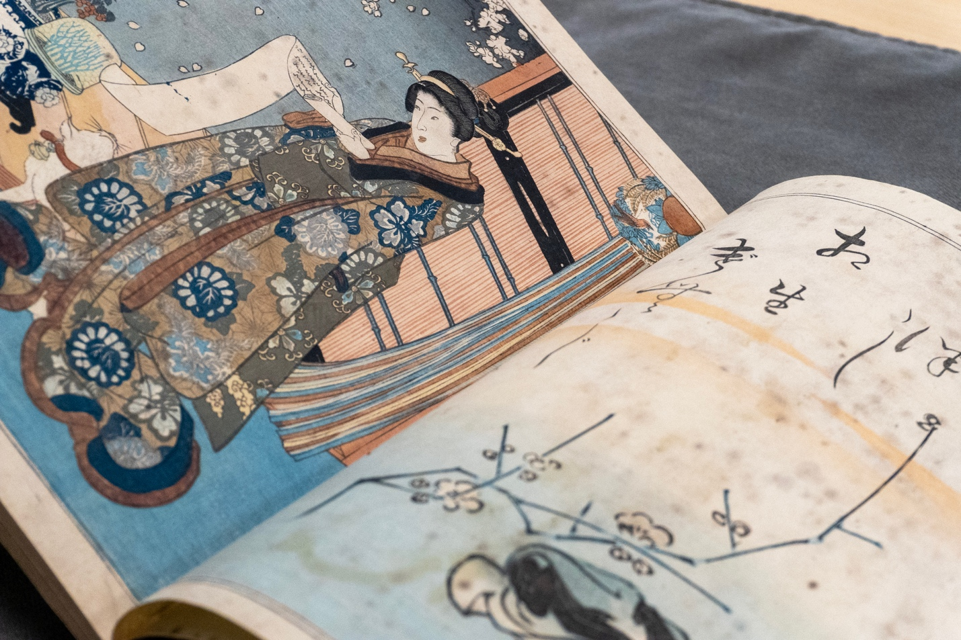

Articles: Create and Deliver Responsive Collections

* PAEI Resources
* Rare Japanese manuscripts and calligraphy works
* Archival descriptions for the Wallace B. Chung and Madeline H. Chung Collection
* The Paper Trail project digital collection
* YWCA Metro Vancouver Archives
* Malcolm Lowry Manuscripts Collection
* Langmann Collection Photo exhibition
* UBC Library at a glance
* Statement of revenue & expenditures

# PAEI Resources

UBC faculty, staff and students now have access to an extensive list of new digital archives, databases, ebooks, print resources and more through UBC Library, thanks to funding provided by the UBC President’s Academic Excellence Initiative (PAEI). The PAEI was established to increase the complement of UBC’s research faculty and fund much needed academic support and infrastructure investments, including essential new library resources.

# Rare Japanese manuscripts and calligraphy works

UBC Library acquires several rare titles as part of its Japanese Collections, thanks in part to support provided by the David Graham Memorial Fund. Digital copies of two of these titles are openly accessible to the public through UBC Open Collections.

# Archival descriptions for the Wallace B. Chung and Madeline H. Chung Collection

Rare Books and Special Collections library staff translate archival descriptions for the Wallace B. Chung and Madeline H. Chung Collection from English into Chinese. These translations improve accessibility of this collection for Chinese-speaking researchers and community members.

# The Paper Trail project digital collection

UBC Library Rare Books and Special Collections partners with The Paper Trail project team to create a digital archival collection of Chinese Immigration (C.I.) certificates. These identity papers were created while Canada’s Chinese Immigration Act was in force from 1885 to 1947. Over 500 C.I. certificates were collected as scans by community historian and curator, Catherine Clement, for the Paper Trail project. The digital archive enables community researchers, students and faculty to easily access and learn from this resource.

# YWCA Metro Vancouver Archives

UBC Library Rare Books and Special Collections partners with YWCA Metro Vancouver to catalogue and preserve over 125 years of YWCA records, dating back to the organization’s origins in the region. With grant funding provided by the UBC Community University Engagement Support (CUES) Fund, this archival project makes these records freely available to the public and research communities.

# Malcolm Lowry Manuscripts Collection

Rare Books and Special Collections announces the (re)launch of the landmark Malcolm Lowry Manuscripts Collection, one of UBC’s oldest keystone research collections. As one of the largest single collections of Malcolm Lowry records worldwide, the collection spans more than six meters of textual records, over 1,000 photographs and a variety of A/V materials.

# Langmann Collection Photo exhibition

Rare Books and Special Collections launches a collaborative exhibition of photographs from the Uno Langmann Family Collection of British Columbia Photographs on display across UBC Library branches for the 2023 Fall term. The collection, donated by Uno and Dianne Langmann and Uno Langmann Limited, consists of more than 20,000 rare and unique early photographs from the 1850s to the 1970s.

# UBC Library at a glance

**Vancouver Campus**

**59K** – Total patron questions

**9.3K** – Online patron questions

**1.1K** – Group presentations

**32.2K** – Presentation participants

**4M** – Total e-books

**5.7M** – Total physical items

**2.7M** – In-person visits

**8.6M** – Website visits

*\*Excludes UBC Okanagan and X̱wi7x̱wa Library*

### Association of Research Libraries ranking, 2022

**24**

### UBC Library e-resource usage*

**101,943** – Unique users

**5,679,846** – Number of logins

**56** – Average logins per user

*\*Based on data for 10 months in FY 2023/24*

## Statement of revenue & expenditures

Vancouver campus

Fiscal year April 1, 2023 – March 31, 2024

|  |  |  |  |  |  |  |  |
| --- | --- | --- | --- | --- | --- | --- | --- |
|  | **Salaries** | **Benefits** | **Collections** | **Other** | **Total** | **Revenue** | **Surplus/Deficit** |
| **Programs** | 21,528,941 | 4,621,477 | 19,873,775 | 3,595,650 | 49,619,843 | 50,944,749 | 1,324,906 |
| **Grants** | 2,811 | 421 | 0 | 148,383 | 151,615 | 156,409 | 4,794 |
| **Gifts** | 230,113 | 40,737 | 561,923 | 71,489 | 904,262 | 934,683 | 30,421 |
| **Project** | (58,774) | (12,182) | 0 | 188,993 | 118,037 | 149,821 | 31,784 |
| **Total expenditures** | 21,703,091 | 4,650,453 | 20,435,698 | 4,004,516 | 50,793,757 | 52,185,662 | 1,391,905 |

## Library expenditures

**44%** - Salaries

**40%** - Collections

**9%** - Benefits

**7%** - Other

# **Section 4**

Inspire with Innovative Spaces and Services

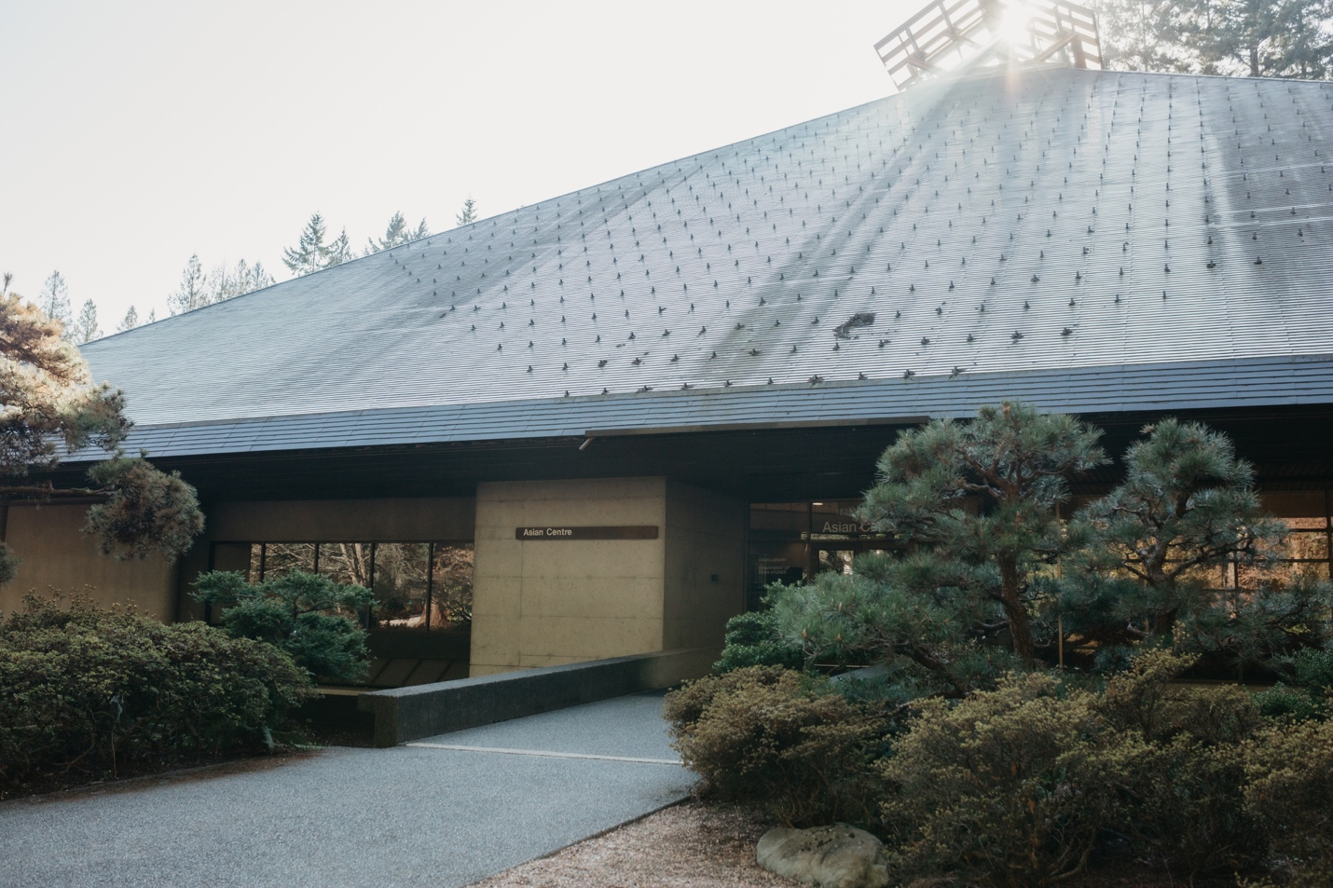

Articles: Inspire with Innovative Spaces and Services

* Meditation at the Library
* Access to new citation management tool
* Digital Media Lab and Leith Wheeler Lab upgrades
* IKBLC Level 2 Learning Concourse upgrades
* Asian Library Renovations
* Writing Consultation expansion
* Seed Lending Library expansion

# Meditation at the Library

UBC Library hosts lightwork meditation workshops at Woodward Library, and guided meditation walks at UBC’s octagonal labyrinth, to help bring together the UBC community in the practice of mindfulness, self-reflection, and meditation. During exam periods, the Chapman Learning Commons pilots a new pop-up meditation space in the Irving K. Barber Learning Centre for students and other patrons to re-group thoughts and pray as needed.

# Access to new citation management tool

## The Library Technology, Discovery, and User Experience team upgrades all staff and public workstations at the library with a new citation management tool, Juris-M. The specialized open-source tool is created for legal research and multilingual scholarship.

# Digital Media Lab and Leith Wheeler Lab upgrades

David Lam Management Research Library and Canaccord Learning Commons make upgrades to three lab spaces, including the Leith Wheeler Investment Research Lab, the Digital Media Lab, and Sound Recording Room, at the UBC Sauder School of Business. Upgrades to the audio-visual system and computer equipment provide users with a faster, more seamless lab experience.

# IKBLC Level 2 Learning Concourse upgrades

The Irving K. Barber Learning Centre open their newly renovated Level 2 Learning Concourse. The space features upgraded seating, larger tables and plenty of power outlets for individual and group study. Students can choose from different types of seating whether they are studying alone, working on a group project or attending an online lecture.

# Asian Library Renovations

UBC Asian Library benefits from two substantial renovation projects on both the upper and main floors of the branch, completed earlier this year. The reimagined space includes extensive improvements to seating and study spaces, much needed repairs, and an overhaul of the book collection stacks and displays.

# Writing Consultation expansion

The Centre for Writing and Scholarly Communication expands to offer in-person writing consultations at four UBC Library Vancouver locations. Students can meet with one of 15 writing consultants from a variety of disciplines to receive feedback on research articles, dissertation chapters, manuscripts for publication and more.

# Seed Lending Library expansion

X̱wi7x̱wa Library joins the UBC Seed Lending Library and establishes a seed collection, attracting new members to the group. The Seed Lending Library actively supports community engagement and the Indigenous Strategic Plan. Academically, it continues to collaborate with UBC Orchard Garden to support the Faculty of Education.

# **Section 5**

Steward the organization

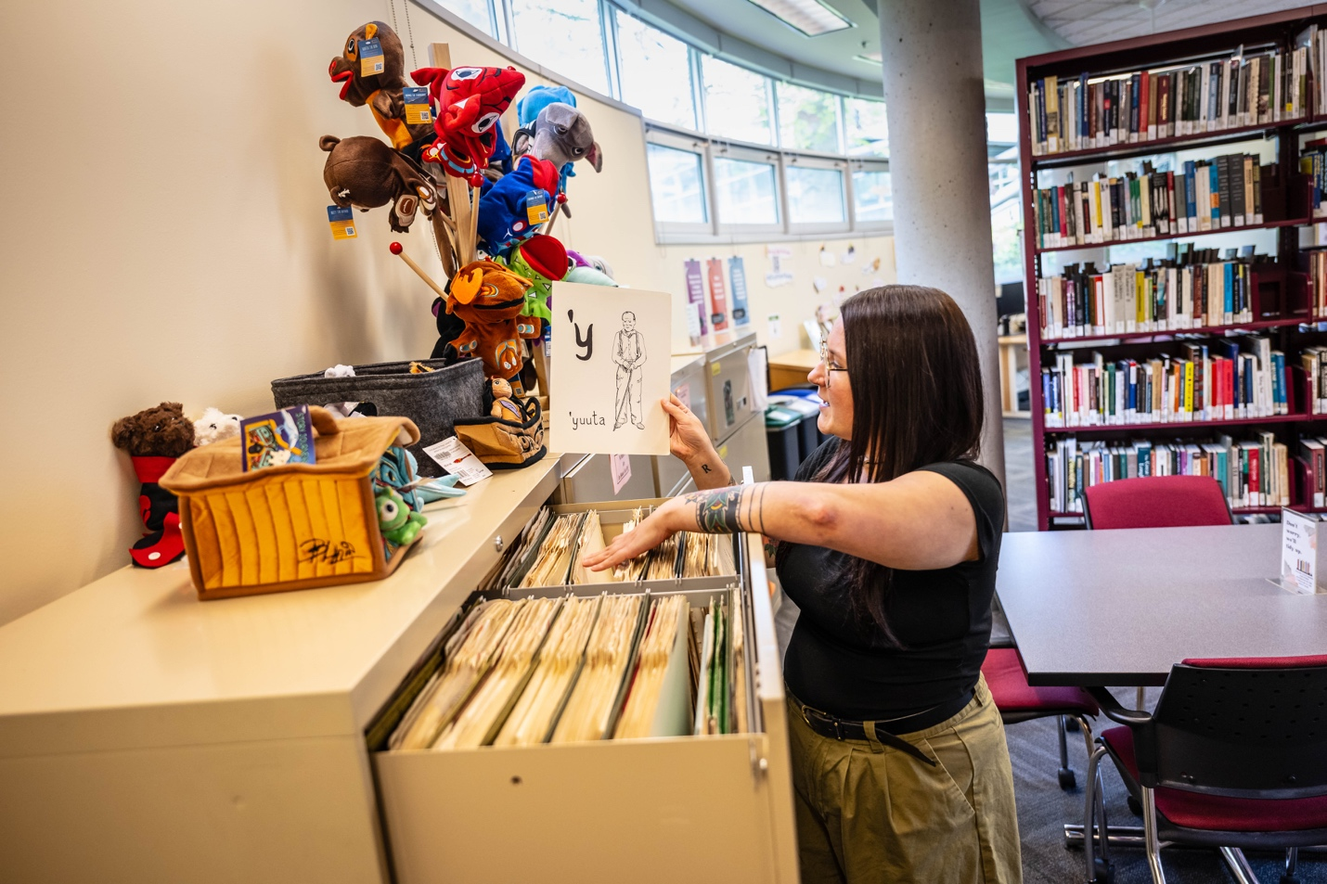

Articles: Steward the organization

* Fudan University Conservator arrives for 100-day visit
* Asian Library Research Lens
* UBC librarians contribute to National Advocacy Framework for Open Educational Resources

# Fudan University Conservator arrives for 100-day visit

Yan Li, librarian and rare books conservator from Fudan University, China, arrives for a 100-day stay at UBC, as part of a cultural and knowledge partnership between UBC Library and Fudan University. This inaugural visit to UBC Library’s Conservation Space is the result of a memorandum of understanding (MOU) between the two institutions that supports the exchange of Eastern and Western conservation knowledge and skills. During her visit, Li works on items from the Puban Collection and other materials held in UBC Asian Library’s collections, documenting her process, and sharing techniques with UBC Conservator Anne Lama.

# Asian Library research lens

UBC Asian Library hosts a new event to highlight how researchers are engaging with the branch’s collections and services. Attendees get a view into a Master of Arts thesis in History that explores the aftermath of the 1906 Hong Kong Typhoon, and a presentation on the Japanese Language Program’s Tadoku Reading Club at UBC.

# UBC librarians contribute to National Advocacy Framework for Open Educational Resources

Erin Fields, Open Education and Scholarly Communications Librarian, and Kayla Lar-son, Acting Head of X̱wi7x̱wa Library contribute to the National Advocacy Framework for Open Educational Resources in Canada, a collaborative effort facilitated by the Canadian Association of Research Libraries (CARL) between a diverse group of open educational resource practitioners and experts from Canada’s post-secondary education system.

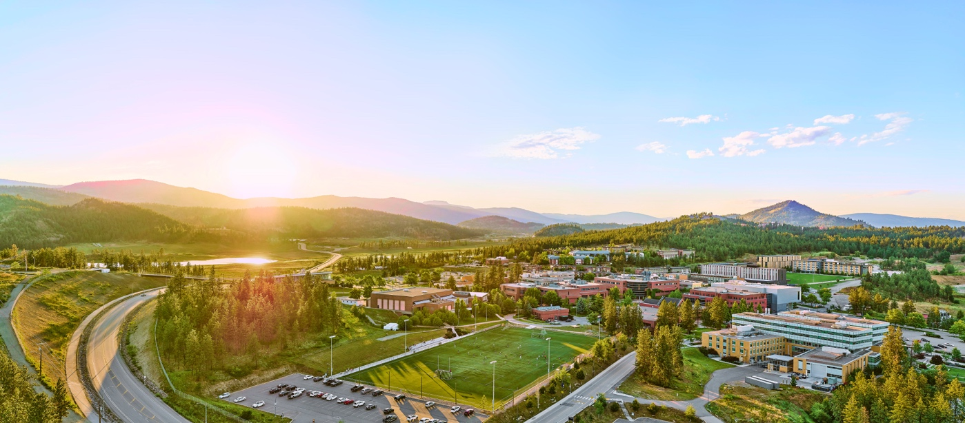

# UBCO Library

In 2023, Robert Janke became interim Chief Librarian and was later awarded the role of Deputy University Librarian. After staff-wide consultation, UBCO Library’s strategic framework was updated and affirmed. The librarians and archivist taught nearly 200 learning sessions, co-authored 14 journal articles, and delivered 32 conference sessions. There was an increase in writing, language, and Academic Integrity Matters appointments and attendance at events in the Student Learning Hub. The Centre for Scholarly Communication provided data and writing consultations, diversified workshop offerings, spearheaded a grant program, bolstered research data support, and developed online resources.

Okanagan Special Collections continued to increase community engagement and partnered with En’owkin Centre to support the Bachelor of Nsyilxcn Language Fluency program. The makerspace saw a significant increase in use, including tours and events. Other highlights included: BC Heritage Walk, a discussion about 2SLGBTQIA+ history in Kelowna, student Zine Fair, and the Legacy of Hope Foundation Exhibition.

Find out more in the:

[2023-2024 Report to UBC Okanagan Senate.](https://library.cms.ok.ubc.ca/wp-content/uploads/sites/116/2024/04/2023LibSenate_RPT_20240126_Rev0.pdf)

# Acknowledgements

I would like to thank the many contributors to this report and those who contributed to its development and production.

-Dr. Susan E. Parker

University Librarian

**Produced by:**

Library Communications and Marketing University

of British Columbia Library Irving K. Barber Learning Centre

1961 East Mall, Vancouver, British Columbia Canada V6T 1Z1

**Design and Production**

Phoebe Chan,

Library Communications and Marketing

August 2024

**Photography Credits**

**Cover**

Phoebe Chan and Matt Patton,

Library Communications and Marketing

**Pages**

1-8, 10-13,15,18-34: Library Communications and Marketing

3,16: Artist kʷəlasəltən (Mack Paul) at the Coast Salish Two-Spirit Pride Mosaic installation (Martin Dee Photography)

3,36: Exterior view of the Commons at UBC Okanagan (Hover Collective / UBCO University Relations)

9: Photographs Conservation

workshop with Chloé Lucas (Hannah McKendry)

14: Networks of Inquiry and Indigenous Education (NOIIE)

17,35: Kayla Lar-Son, Indigenous Programs & Services Librarian at X̱wi7x̱wa Library (Paul Joseph, UBC Brand & Marketing)