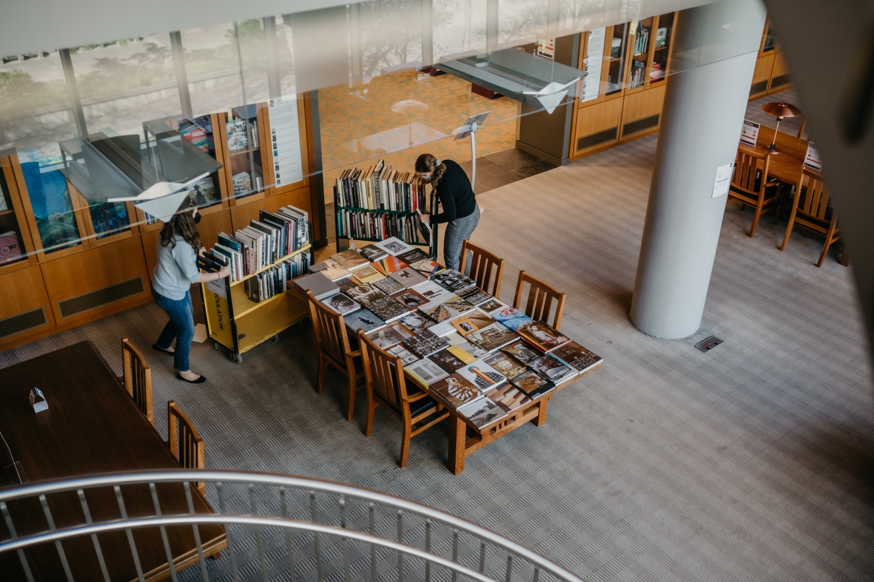

UBC Library
2022/23
Senate Report

Table of Contents

Message from the University Librarian – Pages 3-4

- UBC Library and the Indigenous Strategic Plan – Page 5
- UBC Library and the Inclusion Action Plan – Page 5

Section 1
- Advance Research, Learning and Scholarship – Pages 5-7
- Fundraising for the future – Page 8

Section 2
- Engage with Communities – Pages 9-11

Section 3
- Create and Deliver Responsive Collections – Pages 12-14
- UBC Library at a glance – Page 15
- Statement of revenue & expenditures – Page 16

Section 4
- Inspire with Innovative Spaces and Services – Pages 17-19

Section 5
- Steward the Organization – Pages 20-21
- UBC Okanagan Library Highlights – Page 22
- Acknowledgements – Page 23

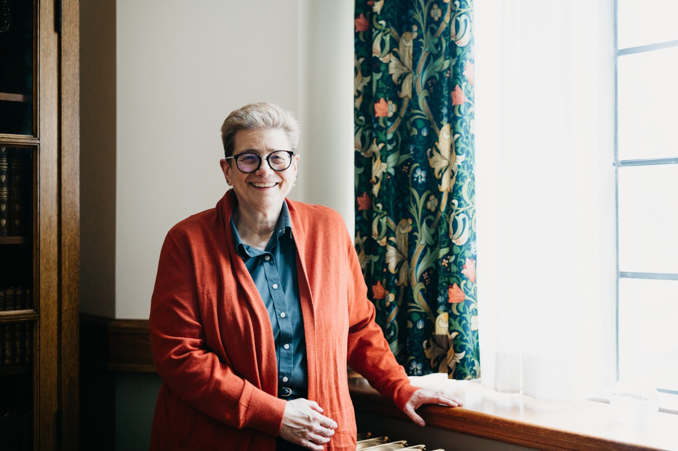

Message from the University Librarian

2022/2023 has been an important year and allowed the library to make significant headway in alignment with the university’s priorities of equity, diversity and inclusion outlined in the Inclusion Action Plan and the Indigenous Strategic Plan.

We have now fully harnessed the power of OpenAthens, our access management service, and can access more fulsome usage data around our e-resources. This has helped us to better understand our library users and provides stronger evidence for data-driven acquisitions and budgetary decisions.

We continue to invest resources in our five strategic directions: advancing research, learning and scholarship, engaging with communities, creating and delivering responsive collections, inspiring with innovative spaces and services and stewarding the organization.

As I embark on my second term as University Librarian, I want to acknowledge the dedication and commitment of UBC Library faculty and staff as we change and evolve with the needs of our community. It is this commitment that ensures UBC Library remains the heart of the university.

– Dr. Susan E. Parker

We acknowledge that the work of UBC Library is situated on the traditional and unceded territories of the xʷməθkʷəy̓əm (Musqueam) and the Syilx (Okanagan) Peoples.

UBC Library and the Indigenous Strategic Plan

In October 2022, 109 library faculty and staff join one of twelve live reading sessions of the Truth and Reconciliation Committee’s Calls to Action. Organized and facilitated by the Library Indigenous Strategic Plan Implementation Team, these 90-minute gatherings give library employees from across both campuses the opportunity to read the 94 Calls to Action out loud. Giving voice to the Calls to Action is an intense and powerful experience for many and are part of an ongoing project to provide the time and space for all library employees to focus on these critical documents so that we can proceed with a shared awareness and understanding.

The Library Executive Team works through the Indigenous Strategic Plan Self-Assessment Toolkit and plans for the assessment toolkit process to be undertaken at the Branch Head level.

UBC Library and the Inclusion Action Plan

In alignment with our work on the UBC Inclusion Action Plan, the library identifies 34 initiatives across both campuses that have been completed or are currently underway. This comprehensive listing is utilized to identify gaps, which are later brought to library leadership for consideration and prioritization—directing our focus over the next fiscal year.

The library also makes significant progress on new hiring guidelines that incorporate equity, diversity and inclusion principles into hiring practices for M&P and CUPE employees, aligning with changes made to hiring practices for Faculty that were implemented in 2021/22.

Section 1
Advance Research, Learning and Scholarship

Articles: Advance Research, Learning and Scholarship

- UBC Library joins the IIIF Consortium
- Transformative agreements are changing open access publishing
- New additions to UBC Library Open Textbook and Open Journal catalogues
- Celebrating undergraduate research
- Punk & Performance: Investigating Canadian Art & Music Through Vinyl
- Supporting research data management at UBC
- Foregrounding Indigenous Perspectives: Community and Collaborator Affinities and Conflicts in Open Education
- IKBLC helps launch new information research grant
- Navigating the streaming media environment
- Author talks
- Fundraising for the future

UBC Library joins the IIIF Consortium

UBC Library joins over 60 global institutions in shaping the International Image Interoperability Framework (IIIF), a set of open standards for delivering high-quality, attributed images and audio-visual files across the web. IIIF plays a key role in the library’s digital infrastructure, used by the Open Collections viewer to deliver images and allow interoperability with digital files from other institutions. As an associate member, UBC Library helps define the roadmap for an open resource alongside a community of global leaders.

Transformative agreements are changing open access publishing

UBC Library’s membership in the Canadian Research Knowledge Network (CRKN) provides new pathways to open access publishing for UBC researchers through transformative agreements. These large-scale license agreements remove financial barriers, like article processing charges and book processing charges, for authors at affiliated institutions. In the 2022-23 fiscal year, CRKN announces new transformative agreements with several major publishers, including Cambridge University Press, Canadian Science Publishing and Wiley.

New additions to UBC Library Open Textbook and Open Journal catalogues

- Pediatric Dermatology: A Primer
  - Authors: Dr. Wingfield E. Rehmus, MD, MPH; Dr. Jamie Phillips; Dr. Lisa Flegel; Dr. Saud Alobaida; and Hannah Podoaba
- Pathology: From the Tissue Level to Clinical Manifestations and Inter-professional Care
  - Authors: Jennifer Kong and Helen Dyck
- Understanding Wildfires: A Case Study for British Columbia
  - Authors: Raluca Radu and Aubree A. McAtee
- Decolonizing the Engineering Curriculum
  - Authors: Pamela Wolf; Alex Gonzalez; Curtis Rattray; Debalina Saha; James Shaw; Nika Martinussen; and Ben Harris
- Canadian Journal of Native Education (CJNE)
  - Issues available: Vol. 18 (No. 1) to Vol. 41 (No. 1)
  - Editors: Jan Hare, Cora Weber-Pillwax, Dwayne Donald, Jo-ann Archibald, et al.

Celebrating undergraduate research

UBC Library launches the UBC Undergraduate Prize in Library Research to recognize student research projects that demonstrate innovative use of library resources. The inaugural prize aims to encourage the use of library collections and services, advance information literacy and promote academic excellence at the undergraduate level. Applicants gain the opportunity to reflect on their research experience and showcase their work beyond the classroom.

Punk & Performance: Investigating Canadian Art & Music Through Vinyl

An exhibition by the Music, Art and Architecture (MAA) Library explores how researchers can use the Long Play (LP) format and its supporting ephemera as rich sources of information. The display features cover art, liner notes and select audio clips from Canadian artists during the 1970s and onwards. Viewers are invited to think of LPs and their accompanying materials as unique research materials and as records of cultural thought from various time periods.

Supporting research data management at UBC

In collaboration with Advanced Research Computing, UBC Library co-publishes a report on how to support UBC researchers with accessing training and services on digital research skills. As a cosponsor of UBC’s research data management strategy, the library works with the Office of the Vice-President, Research and Innovation and the Office of the Chief Information Officer to chart the plan for enhancing research data management across the university.

Foregrounding Indigenous Perspectives: Community and Collaborator Affinities and Conflicts in Open Education

UBC librarians embark on a new collaborative research project that aims to address a fundamental problem in how open educational practices approach Indigenous Knowledges, and instead replicate colonial concepts of ownership and knowledge transfer. The project, awarded the Practicing Librarian Grant by the Canadian Association of Research Libraries, includes co-investigators from UBC’s Vancouver and Okanagan campuses as well as Toronto Metropolitan University and BCcampus.

IKBLC helps launch new information research grant

As one of six academic libraries in British Columbia who support the Community Scholars Program, UBC Library’s Irving K. Barber Learning Centre helps launch a grant opportunity for current program participants. Two Information Research Grants, each valued at $6k, are awarded to Kiwassa Neighbourhood House and Battered Women’s Support Services to support projects that foster information research and turn research into action.

Navigating the streaming media environment

With the rise of the streaming format, the library partners with Ithaka S+R to examine streaming media licensing and purchasing at academic libraries. The research study surveys 24 universities on their decision-making related to streaming media, and interviews faculty members about their use of video in the classroom. Findings will inform academic libraries’ strategies for licensing and managing streaming media in a rapidly evolving landscape.

Author talks

Faculty, students and staff engage in discussion with Dr. Gregory Betts, winner of the 2022 Basil-Stuart Stubbs Prize for his book Finding Nothing: The VanGardes, 1959-1975. The book explores Vancouver’s cultural transformations from 1959 to the early 1970s. The David Lam Library hosts Dr. Jonathan Berkowitz, author of Tales From the Word Guy: What Your English Teacher Never Taught You, to discuss his book on the history and evolution of the English language.

Fundraising for the Future

Donor support enables the library to enhance student learning, help researchers find answers and advance knowledge to its fullest potential. Donations can help build spaces, connect ideas, and allow the library to provide a margin of excellence beyond what public dollars provide.

Inbound channels

44% – Web
24% – Mail
18% – Personal Solicitations
14% – Phone

Total funds raised

$2.4M

Number of gifts

415

Funds raised

$1.48M – Pledges
$607k – Gifts-in-kind
$177k – Realized bequests
$173k – Outright donations

Section 2

Engage with communities

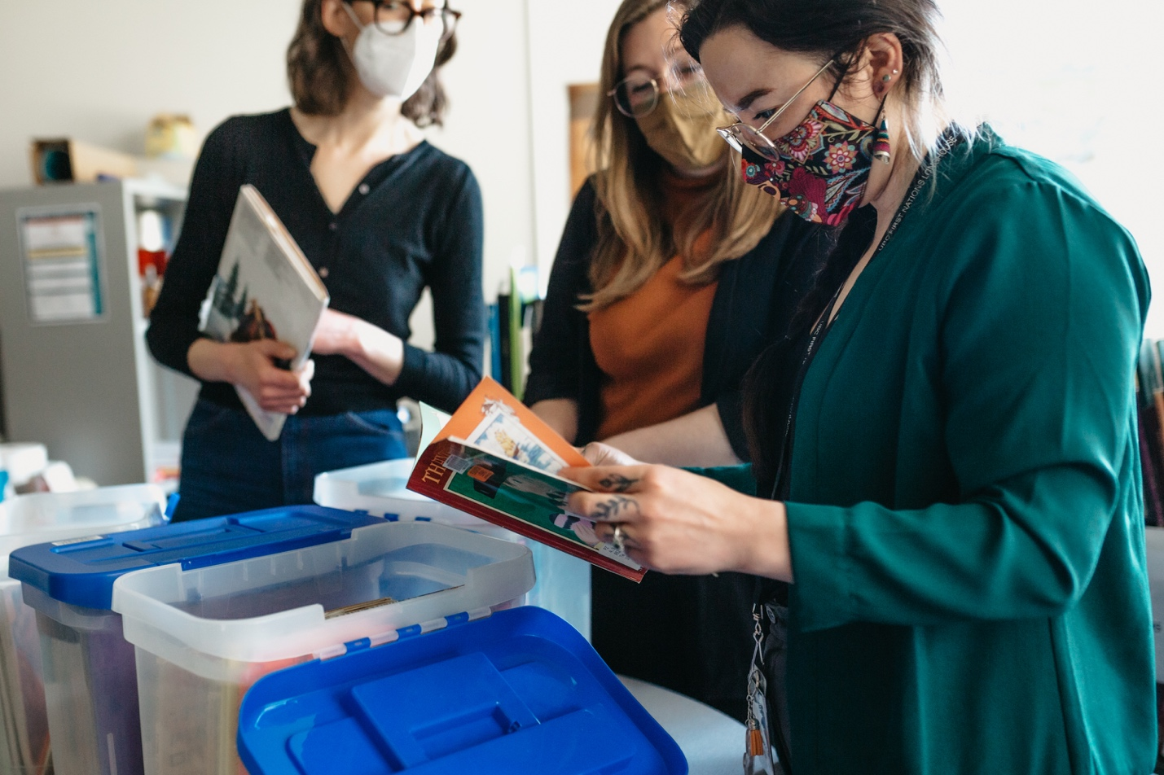

Articles: Engage with communities

- Critical Indigenous literacy kits
- Leaving No One Behind, No One Outside
- EDI Scholars-in-Residence Program
- Finding Forgiveness
- Activism in the Arts: I’ve Got U Under My Skin: AIDS & Classical Music exhibition
- UBC Library at the Climate Emergency Fair
- Leslie Cheung 張國榮: Hong Kong Icon (1956-2003)
- Remembering MMIWG2S+

Critical Indigenous literacy kits

Librarians at UBC Vancouver’s Education Library, Xwi7xwa Library and UBC Okanagan Library confront problematic Indigenous representations in children’s literature by creating Critical Indigenous Literacy Kits for educators that focus on topics like cultural appropriation, myth and folklore, and residential schools. Rather than removing problematic books from library shelves, the kits contextualize the books, providing instructors with suggested resources and guided questions to encourage classroom discussion.

Leaving No One Behind, No One Outside

Xwi7xwa Library launches an exhibit during Indigenous Peoples Month in June 2022 that celebrates the diversity and complexity of Indigenous Languages in British Columbia. Inspired by UNESCO’s International Decade of Indigenous Languages, the exhibit features materials from the branch’s Indigenous language collection.

EDI Scholars-in-Residence Program

UBC Library and the Irving K. Barber Learning Centre introduce the Equity, Diversity, and Inclusion (EDI) Scholars-in-Residence Program, with support from the Peña Fund. Open to scholars who hold degrees in any discipline, the program establishes a new public lecture series and opportunities for UBC students, staff and faculty to book one-on-one consultation sessions with the scholars. In turn, scholars are afforded full access to library resources, space in the Peña Room, and an honorarium.

Finding Forgiveness

In collaboration with the Arts Club Theatre Company and the Nikkei National Museum and Cultural Centre, the library presents an illuminating discussion panel on World War II Japanese Canadian Internment at the Museum of Vancouver. The event includes a special preview of the Arts Club Theatre play, Finding Forgiveness, a stage adaptation of Mark Sakomoto’s novel Forgiveness.

Activism in the Arts: I’ve Got U Under My Skin: AIDS & Classical Music exhibition

The Music, Art and Architecture Library presents an exhibition that explores a moment of activism in the musical arts propelled by the early years of the AIDS (Acquired Immunodeficiency Syndrome) epidemic. The exhibition includes selections such as “All the Rage” (1993) by Bob Ostertag and “Positive Women: Susan” (1997) by Janika Vandervelde.

UBC Library at the Climate Emergency Fair

The Library #ClimateAction Team (L#CAT) attends the UBC Climate Emergency Fair to engage with students, faculty, staff and other sustainability groups across campus. Taking place in the AMS Student Nest, the L#CAT booth showcases various learning materials including climate-related books from the library’s collections.

Leslie Cheung 張國榮: Hong Kong Icon (1956-2003)

The Asian Library and the Department of Asian Studies co-present an exhibition commemorating the 20th anniversary of the passing of Leslie Cheung Kwok-wing, Hong Kong actor, singer and performer. The exhibition features a wide array of items—from books and scholarly journals, to vinyl records and original film posters from some of Cheung’s most popular works.

Remembering MMIWG2S+

Xwi7xwa Library presents a book display in honour of the 32nd Annual MMIWG2S+ Memorial March. Visitors are invited to learn more about missing and murdered Indigenous women, girls and two-spirit people (MMIWG2S) in Canada, as well as ways to support the Calls to Justice.

Beginning in 1992 after the murder of a woman on Powell Street in Vancouver, the MMIWG2S+ Memorial March takes place annually in Vancouver’s Downtown Eastside.

Section 3

Create and deliver responsive collections

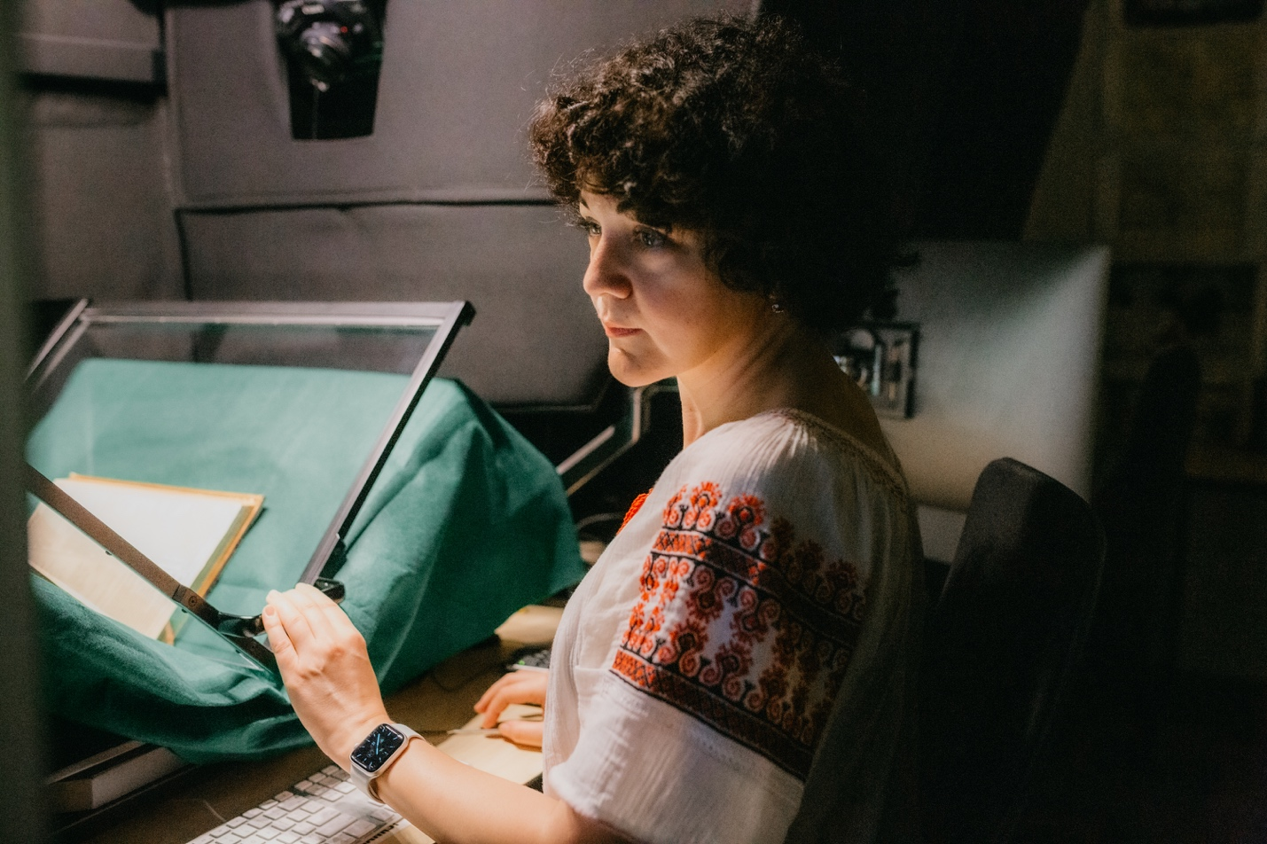

Articles: Create and deliver responsive collections

- Vancouver Sun digital archives
- Malcolmson Photography Book Collection
- Kamishibai Propaganda Plays digital collection
- UBC Library at a Glance
- Digitization of Shakespeare's First Folio
- Statement of revenue & expenditures
- Volkoff Family archives
- NAACP Papers digital archives
- Joan Gillis Fonds added to CCUNESCO Memory of the World Register

Vancouver Sun digital archives

UBC Library acquires access to the digital archives of the Vancouver Sun newspaper from 1912 to 2010, a valuable new source for scholarship and teaching. This acquisition contributes to a collaborative licensing effort through the British Columbia Electronic Library Network that grants all British Columbia and Yukon residents free online access to three Canadian historical newspaper archives: the Vancouver Sun (1912-2010), the Times Colonist (1884-2010) and The Province (1894-2010).

Malcolmson Photography Book Collection

The Music, Art and Architecture Library acquires the Harry and Ann Malcolmson Photography Book Collection, which encompasses nearly 600 items in a variety of formats including monographs, trade publications, exhibition catalogues, photobooks and artists’ books. Canadian artists associated with the Vancouver School of photoconceptualism is a focus within the collection, as are materials published by local institutions such the Vancouver Art Gallery, the Morris and Helen Belkin Art Gallery and others.

Kamishibai Propaganda Plays digital collection

Librarians and student staff from Digital Services and the Asian Library work with UBC Department Head of Asian Studies Dr. Sharalyn Orbaugh to digitize her extensive private collection of World War II-era plays from Japan, to make them publicly available online through UBC Open Collections. This extremely rare collection of plays, produced in the 1930s and 40s as wartime propaganda materials, is presented in a format known as kamishibai, or paper theatre.

UBC Library at a glance
Vancouver campus

64.2K – Total patron questions

15.3K – Online patron questions

993 – Group presentations

28.9K – Presentation participants

3.8M – Total e-books

5.6M – Total physical items

2.4M – In-person visits*

9.7M – Website visits

*Excludes UBC Okanagan and Xwi7xwa Library

Association of Research Libraries ranking, 2021

29

UBC Library e-resource usage*

79,744 – Unique users

7,059,924 – Number of logins

89 – Average logins per user

*Based on data for 10 months in FY 2022/23

Digitization of Shakespeare's First Folio

UBC Library digitizes its first edition of William Shakespeare’s Comedies, Histories, & Tragedies, making this rare text openly accessible to the public through Open Collections. The process to digitize the First Folio is facilitated over the course of a year, thanks to the collaborative efforts of the library’s Conservator, Digital Projects team and Rare Books and Special Collections.

While the process takes time and requires meticulous attention to detail, due to the fragility of the Folio’s binding and small margins, the end result is a beautiful, high-resolution digital copy that anyone, anywhere in the world, can freely explore. The digitization of the Folio represents a major milestone in UBC’s digital media plan for the volume and aligns with a mandate to ensure digital access to this rare cultural treasure.

Statement of revenue & expenditures
Vancouver campus

Fiscal year April 1, 2022 – March 31, 2023

 | Salaries | Benefits | Collections | Other | Total | Revenue | Surplus/Deficit
Programs | 19,317,544 | 4,177,636 | 19,171561 | 2,672,075 | 45,338,816 | 45,521,345 | 185,529
Grants | 0 | 0 | 0 | 158,325 | 158,325 | 150,993 | (7,332)
Gifts | 149,962 | 31,076 | 466,021 | 81,864 | 728,923 | 1,207,417 | 478,494
Project | 173,106 | 36,305 | 0 | 1,811,394 | 2,020,705 | 1,786,793 | (233,912)
Total expenditures | 19,640,612 | 4,245,017 | 19,637,583 | 4,723,558 | 48,246,770 | 48,666,549 | 419,779

Library expenditures

40% - Collections
41% - Salaries
9% - Benefits
10% - Other

Vollkoff Family archives

UBC Archives receives the collected archives of the Volkoff Family. Through manuscripts, correspondence, research notes, academic records and more, the fonds documents the personal lives and careers of prominent theoretical physicist Dr. George Volkoff (1914- 2000) and microbiology researcher Olga Volkoff (1912-2005).

NAACP Papers digital archives

The Law Library acquires access to a digitized collection of primary source materials documenting the Black freedom struggle in 20th-Century America. The collection chronicles the major campaigns of the NAACP (National Association for the Advancement of Colored People) from 1909 to 1972. Funding is provided by the UBC President’s Academic Excellence Initiative with additional acquisition support by Koerner Library.

Joan Gillis Fonds added to CCUNESCO Memory of the World Register

UBC Library’s Joan Gillis Fonds is added to the Canadian Commission for UNESCO’s Canada Memory of the World Register, which highlights exceptional works and documents that reflect the wealth and diversity of Canada’s documentary heritage. The fonds consists of the incoming correspondence, dated between 1942 to 1948, to Joan Gillis from a group of young Japanese Canadian friends. The letters provide unique insight into the Japanese Canadian internment and forced dispersal from the perspective of 13 teenagers, who write about their day-to-day lives at work camps and farms in British Columbia, Manitoba and Alberta.

Section 4

Inspire with innovative spaces and services

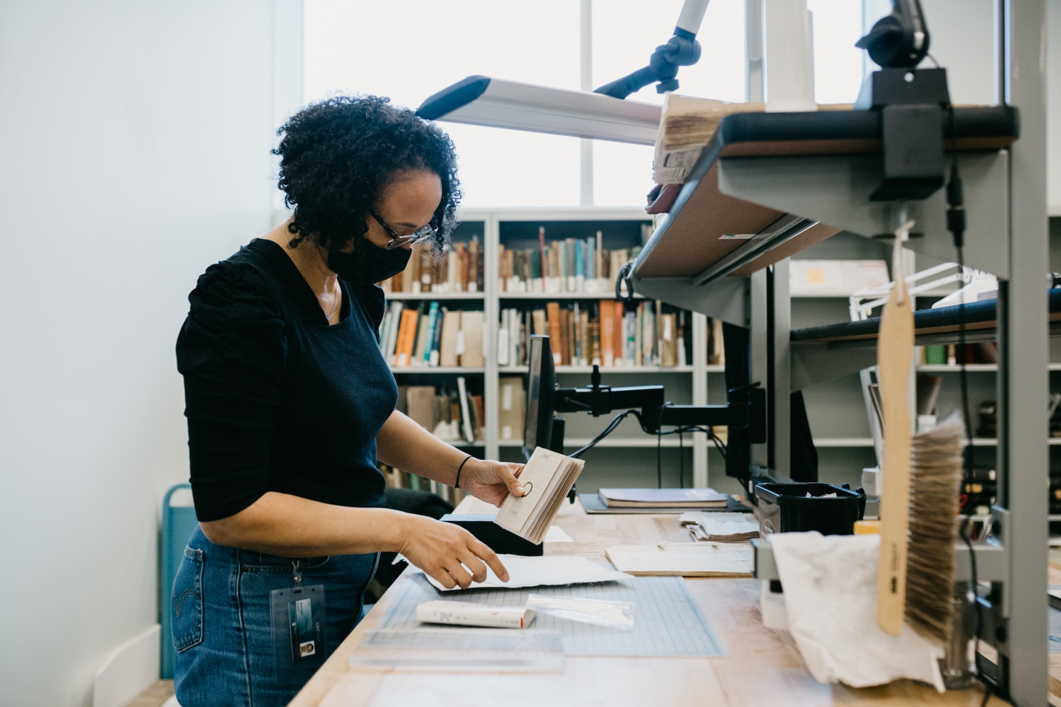

Articles: Inspire with innovative spaces and services

- Conservation Space opens
- Upgraded study spaces at Koerner Library
- New study spaces and wall art at the MAA Library
- Wayne Deans Investment Analysis Centre upgrades
- Piloting dual display stations
- Peña Room opens

Conservation Space opens

UBC Library’s newest specialized space dedicated to the conservation, preservation and treatment of the library’s physical materials opens in the Irving K. Barber Learning Centre. Work done at the Conservation Space includes materials from all UBC Library branches, with a special focus on materials from Rare Book and Special Collections and collaborative projects with Digital Initiatives.

The space significantly expands the scale and scope of work that the library’s Conservation team can take on, with improved access to large worktables, storage space, better security infrastructure, and new equipment. The space also offers new opportunities for teaching and learning, through class tours, professional development workshops, and knowledge exchange with international partners.

Upgraded study spaces at Koerner Library

Koerner Library undergoes space improvements on Levels 1 and 2 to install 250 new study carrels. Electrical upgrades in the space provide 25% more powered carrel spaces for library users to keep their devices charged.

New study spaces and wall art at the MAA Library

The Music, Art and Architecture Library makes space improvements to areas of Level 4, creating additional study spaces using repurposed study seats and tables. The north and south walls are revitalized with framed reproduction photographs from the previously deaccessioned architecture portfolio of the Carnegie Art Reference Set for Colleges.

Wayne Deans Investment Analysis Centre upgrades

The Wayne Deans Investment Analysis Centre receives technology upgrades to facilitate hybrid teaching and learning experiences for UBC Sauder School of Business faculty and students. Supported by Canaccord Learning Commons staff, the space provides access to top financial databases. Improvements include new television screens, speaker and microphone upgrades, and support for USB-C and Ethernet wireless connections.

Piloting dual display stations

Public-access laptop dual display stations are installed at Koerner Library and the Chapman Learning Commons as part of a new pilot program. With this new flexible workspace configuration, library users can connect their own device to a secondary monitor, keyboard and mouse through a universal dock. Following the successful pilot, additional stations are rolled out to several more UBC Library branches.

Peña Room opens

The Peña Room (previously the Lillooet Room) opens with new upgrades through a generous gift from Marissa and Antonio Peña. A ribbon-cutting celebration unveils new space improvements that facilitate a range of learning activities. Part of the Chapman Learning Commons in the Irving K. Barber Learning Centre, the Peña Room regularly hosts workshops, events and other programming.

Section 5

Steward the Organization

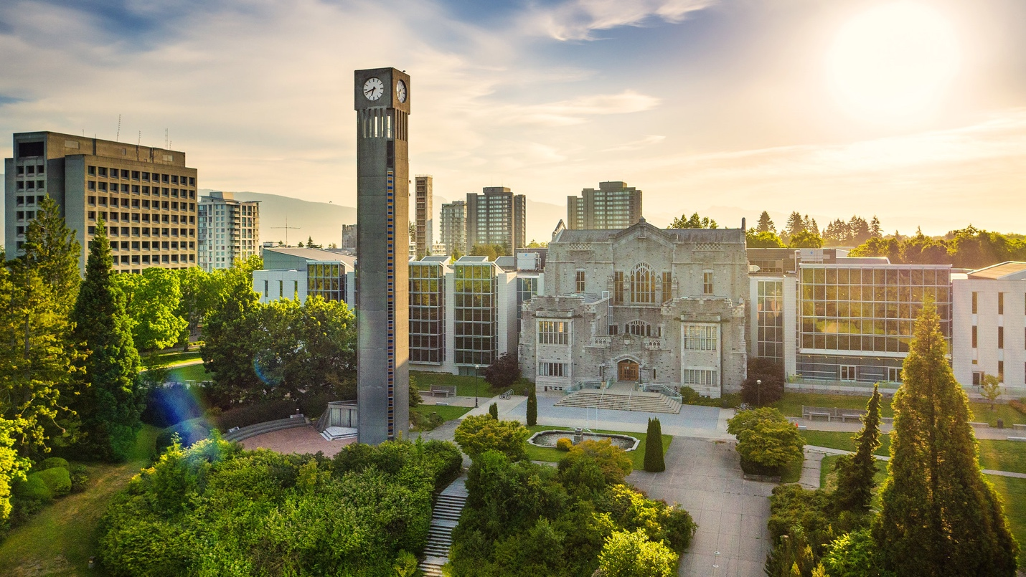

Articles: Steward the Organization

- New library mentorship program
- RBSC staff wins the 2022 President’s Staff Award for Wellbeing
- Dr. Susan E. Parker begins 1-year term as president of ARL
- Xwi7xwa Librarian chosen as an ALA Emerging Leader

New library mentorship program

The Irving K. Barber Learning Centre launches a mentorship program to support aspiring academic librarians and archivists from UBC’s School of Information. Graduate students from the MLIS and MAS programs are matched with UBC librarians and archivists, gaining the opportunity to network and receive professional advice in an informal setting.

RBSC staff wins the 2022 President’s Staff Award for Wellbeing

Felicia de la Parra, Senior Library Assistant at Rare Books and Special Collections, receives the 2022 President’s Staff Award for Wellbeing. This award recognizes de la Parra for her efforts at fostering community and networks of care by creating welcoming spaces, bringing people together through team-building events, and connecting her colleagues with wellbeing and professional development resources.

Dr. Susan E. Parker begins 1-year term as president of ARL

Dr. Susan E. Parker is elected president of the Association of Research Libraries (ARL) for a one-year term. The Board of Directors is the governing body of the association and represents the interests of ARL member libraries in directing the business of the association. This includes establishing operating policies, budgets, fiscal oversight, modifying the ARL mission and objectives and representing the association to the community.

Xwi7xwa Librarian chosen as an ALA Emerging Leader

Karleen Delaurier-Lyle, Information Services Librarian at the Xwi7xwa Library, is selected as one of ALA’s Emerging Leaders for the 2023 cohort. This professional development program enables early-career library faculty to participate in problem-solving work groups, network with peers, and gain an inside look into ALA structure while providing the opportunity to serve in a leadership capacity.
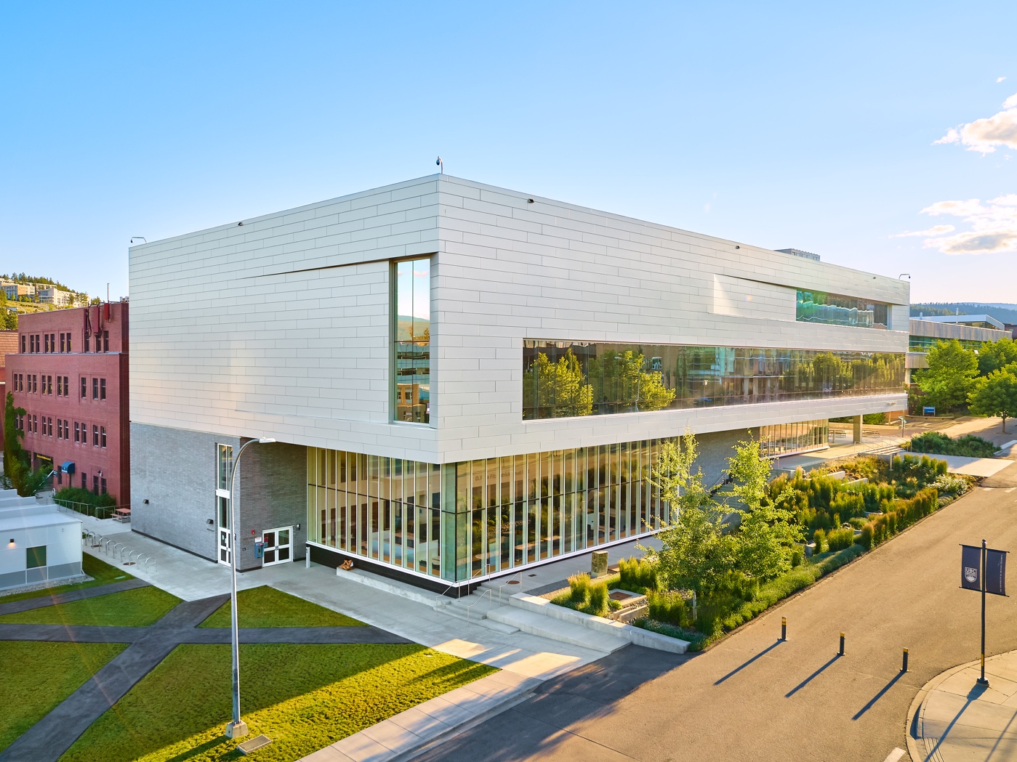

UBCO Library

The library continued to make significant contributions to the Okanagan campus in 2022. This involved expanding instructional efforts, steady growth in the research enterprise, contributing to community partnership initiatives, and providing inclusive spaces with our service-focused team. Highlights include librarians delivering 237 instructional sessions, increases in Student Learning Hub appointments, continued growth in Academic Integrity Matters referrals, cross-campus progression in open education initiatives including the Open Textbook Publishing Guide, the development of new Centre for Scholarly Communication workshop content, increased community participation in the British Columbia Regional Digitized History project, an array of engaging makerspace-led activities, and the welcomed return to a full schedule of on-campus events.

Find out more in the:
2022-2023 Report to UBC Okanagan Senate

Acknowledgements

I would like to thank the many contributors to this report and those who contributed to its development and production.

-Dr. Susan E. Parker
University Librarian

Produced by:
Library Communications and Marketing University
of British Columbia Library Irving K. Barber Learning Centre
1961 East Mall, Vancouver, British Columbia Canada V6T 1Z1

Design and Production
Phoebe Chan and Matt Patton,
Library Communications and Marketing
August 2023

Photography Credits

Pages
1,3,6,12,16,21: Library Communications and Marketing
24: Exterior view of the Irving K. Barber Learning Centre at UBC Vancouver
(Hover Collective / UBC Brand & Marketing)
26: Exterior view of the Commons at UBC Okanagan
(Hover Collective / UBCO University Relations)

